CSE 3033 OPERATING SYSTEMS PROJECT #3 REPORT
THREADS AND SYNCHRONIZATION

Mustafa Abdullah Hakkoz – 150117509
Enes Garip – 150116034

In this project, we implement a multi-thread program that manipulates the text files. The program gets arguments like as:

Usage: ./project3 -d <filename> -n <#readthreads> <#upperthreads> <#replacethreads> <#writethreads>\n"

The program reads from a text file line by line with the help of read threads. Then all lines are stored in an array. The upper threads convert array content to uppercase.(There is a problem in our code so this part is not work properly.) The replace threads replace spaces with underscores.
The write threads reads the manipulated array and write back to the text file.

The aim of the project is managing multi-threads. Working with multi-threads are difficult because each thread want to do some processes in the same array so we use synchronizers like mutexes and semaphores. In the code we use lock system to prevent the collisions of threads.

DETAILS
- First of all, we include headers to use threads and semaphores.
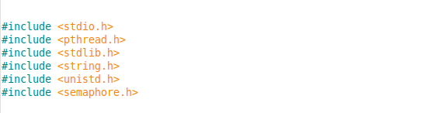
- A struct that holds information about each single line. We used it to build an array.
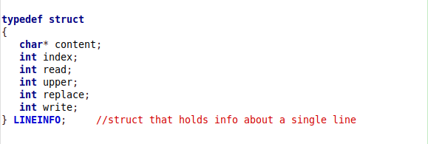

- Mutex initializers for the lock system.
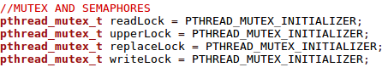

- We implement all of handlers and their secondary functions, but only read threads are working properly. We didn’t manage to fire them at all.
The read threads reads the test.txt file:
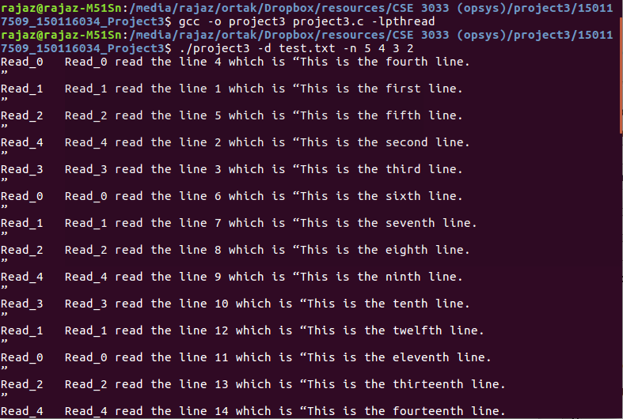

- Uppercase thread handler function.
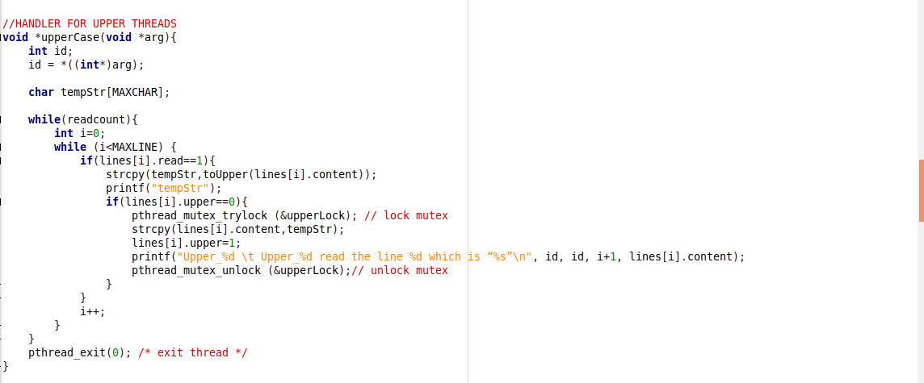

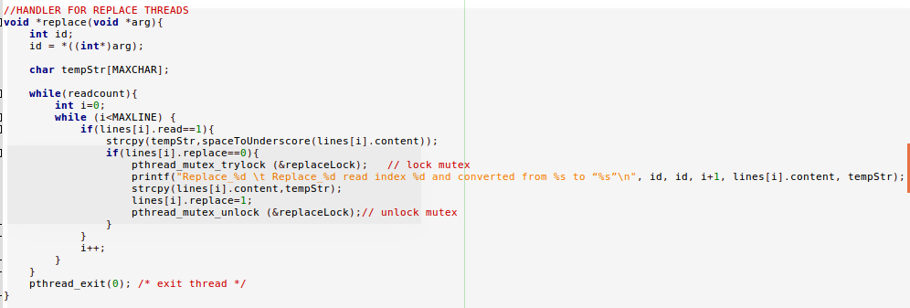

- Replace thread handler function.

- Writer thread handler function.
